***1.Bug Title:* User Unable to Create Profile without inputting information in an Optional field(LinkedIn Url field)**

***2.Severity :***

* **High**

***3.Reproducibility***

* **Always**

***4.Bug Type/Category***

* **Functionality**

***5.Steps to Reproduce***

* **Go to** [**https://qa-assessment.pages.dev/**](https://qa-assessment.pages.dev/)
* **Enter valid information only in the mandatory input fields**
* **Click on the “submit” button**

***6.Expected Results***

* **User profile is supposed to be successfully created when on submit button is clicked even of no information is entered in the optional fields**

***7.Actual Results***

* **Error message is shown at the LinkedIn Url field after the “submit “ button is clicked**

***8.Screenshot/screenrecord link of bug***

**-screenShot**

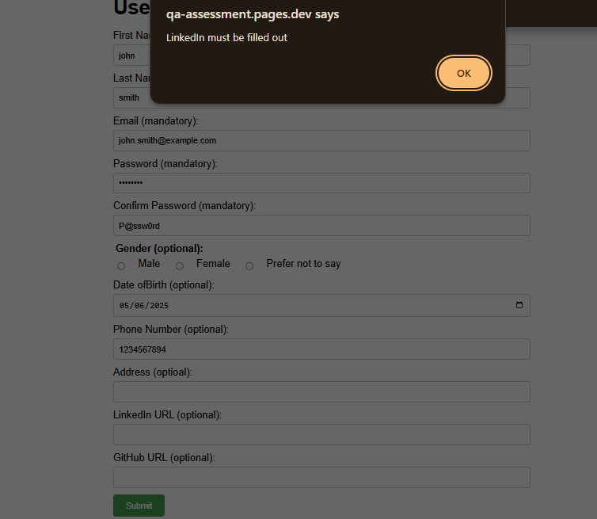

***9.Device Information***

**- Occurs on all Devices**

**-Connection type and speed: Mobile data / 17Mbps**